2.5 BANKING LAW AND OPERATIONS
OBJECTIVE
The objective is to familiarize the students with the law and operations of Banking.

Unit 1: NEGOTIABLE INSTRUMENTS 10 Hrs
Introduction – Meaning & Definition – Features – Kinds of Negotiable Instruments: Meaning,
Definition & Features of Promissory Notes, Bills of Exchange, Cheques - Crossing of Cheques –
Types of Crossing – Endorsements: Meaning, Essentials & Kinds of Endorsement.

Unit 2: BANKER AND CUSTOMER RELATIONSHIP 10 Hrs
Introduction – Meaning of Banker – Bank - Meaning of Customer – General & Special Relationships.

Unit 3: BANKING OPERATIONS 18 Hrs
Collecting Banker: Meaning – Duties & Responsibilities of Collecting Banker – Holder for Value –
Holder in Due Course - Statutory Protection to Collecting Banker
Paying Banker: Meaning – Precautions – Statutory Protection to the Paying Banker – Dishonor of
Cheques – Grounds of Dishonor – Consequences of wrongful dishonor of Cheques.
Lending Operations: Principles of Bank Lending – Kinds of lending facilities such as Loans, Cash
Credit, Overdraft, Bills Discounting, Letters of Credit – NPA: Meaning, circumstances & impact –
regulations of priority lending for commercial banks.

Unit 4: CUSTOMERS AND ACCOUNT HOLDERS 12Hrs
Types of Customers and Account Holders - Procedure and Practice in opening and operating accounts
of different customers including Minors - Meaning & Operations of Joint Account Holders,
Partnership Firms, Joint Stock companies, Executors and Trustees, Clubs and Associations and Joint
Hindu Undivided Family.

Unit 5: BANKING INNOVATIONS 06 Hrs
New technology in Banking – E-services – Debit and Credit cards. Internet Banking, ATM,
Electronic Fund Transfer, MICR, RTGS, NEFT, DEMAT.

SKILL DEVELOPMENT:
• Collect and fill account opening form of SB A/c or Current A/c
• Collect and fill pay in slip of SB A/c or Current A/c.
• Draw specimen of Demand Draft.
• Draw different types of endorsement of cheques.
• Draw specimen of Travellers Cheques / Gift cheques / Credit cheques.
• List various customer services offered by atleast 2 banks of your choice.

Unit 1: NEGOTIABLE INSTRUMENTS 10 Hrs

Introduction – Meaning & Definition – Features – Kinds of Negotiable Instruments: Meaning, Definition & Features of Promissory Notes, Bills of Exchange, Cheques - Crossing of Cheques –
Types of Crossing – Endorsements: Meaning, Essentials & Kinds of Endorsement.

Introduction –Negotiable Instruments Introduction
• A document that promises payment to a specified person or the assignee

• This type of instrument is a transferable, signed document that promises to pay the bearer a sum of money at a future date or on demand.

• Examples are bills of exchange, promissory notes, drafts and certificates of deposit.

Meaning :What are Negotiable Instruments?
A negotiable instrument is actually a written document. This document specifies payment to a specific person or the bearer of the instrument at a specific date. So we can define a bill of exchange as “a document signifying an unconditional promise signed by the person giving promise, requiring the person to whom it is addressed to pay on demand, or at a fixed date or time, a certain sum to or to the order of a specified person, or to bearer.”

Negotiation refers to transfer of title (right to receive payment) from one person to another. The instruments that help the person to achieve this transfer are called negotiable instruments.

Definition: The Negotiable instruments act does not define the negotiable instrument but as per section 13, a “Negotiable instrument” means a promissory note, bill of exchange and cheque payable either to order or bearer.

Features of Negotiable Instruments
- Easily Transferable: A negotiable instrument is easily and freely transferable. There are no formalities or much paperwork involved in such a transfer. The ownership of an instrument can transfer simply by delivery or by a valid endorsement.
- Must be Written: All negotiable instruments must be in writing. This includes handwritten notes, printed, engraved, typed, etc.
- Time of Payment must be Certain: If the order is to pay when convenient then such an order is not a negotiable instrument. Here the time period has to be certain even if it is not a specific date. For example, it is acceptable if the time of payment is linked with the death of a specific individual. As death is a certain event.
- Payee also must be certain: The person to whom the payment is to be made must be a specific person or persons. Also, there can be more than one payee for a negotiable instrument. And “person” includes artificial persons as well, like body corporates, trade unions, chairman, secretary etc.
- Transfer free from defect: It confers an absolute and good title on the transferee. Even if the transferor has a bad title to the instrument, he can still pass on a good title to any holder who takes it in good faith and without negligence and for valuable consideration. Thus it cuts off prior defects in the instruments.
- Right to sue: It confers a right on the holder to sue in his own name, in case of need.
- No notice of transfer: The transferor of a negotiable instrument can simply transfer the document, without serving any notice of transfer to the party who liable on the instrument to pay.
- Presumptions regarding negotiable instrument: It is presumed that the instrument has been obtained for consideration. Also, there are other presumptions regarding date, time of acceptance, time of transfer, order of endorsement, stamp, holder to be holder in due course. (Section 118-119 of the NI Act).

Presumptions about Negotiable instruments:

118. Until the contrary is proved, the following presumptions shall be made :—
 |  | of consideration
(a) |  | that every negotiable instrument was made or drawn for consideration, and that every such instrument, when it has been accepted, indorsed, negotiated or transferred, was accepted, indorsed, negotiated or transferred for consideration;
 |  | as to date
(b) |  | that every negotiable instrument bearing a date was made or drawn on such date;
 |  | as to time of acceptance
(c) |  | that every accepted bill of exchange was accepted within a reasonable time after its date and before its maturity;
 |  | as to time of transfer
(d) |  | that every transfer of a negotiable instrument was made before its maturity;
 |  | as to order of indorsements
(e) |  | that the indorsements appearing upon a negotiable instrument were made in the order in which they appear thereon;
 |  | as to stamp
(f) |  | that a lost promissory note, bill of exchange or cheque was duly stamped;
 |  | that holder is a holder in due course
(g) |  | that the holder of a negotiable instrument is a holder in due course : provided that, where the instrument has been obtained from its lawful owner, or from any person in lawful custody thereof, by means of an offence or fraud, or has been obtained from the maker or acceptor thereof by means of an offence or fraud, or for unlawful consideration, the burden of proving that the holder is a holder in due course lies upon him.

Kinds of Negotiable Instruments:

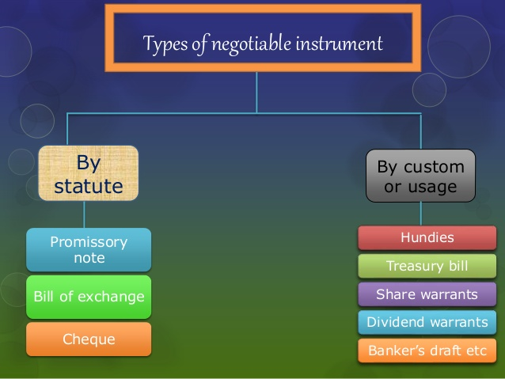

Negoriable by statute:
- Promissory note
- Bill of exchange
- Cheque

Promissory Notes
Meaning: A Promissory Note is an instrument in writing. It contains an unconditional undertaking or promise, signed by the maker to pay a certain sum of money to a certain person. Unlike, Bills of exchange, there is no need of acceptance of Promissory Notes as here the payer is himself the maker of the note. He, himself promises to make the payment. Hence, only two parties are involved here, one is the maker and another one is the payee.
Definition:The promissory note is a signed document of written promise to pay a stated sum to a specified person or the bearer at a specified date or on demand.
For instance, A has to pay ₹ 10000 to B. A makes a promissory note in which he promises to pay ₹ 10000 to B on 25th September 2018. Therefore, A is the maker, payer or the drawer of the promissory note whereas B is the receiver or the payee of the promissory note.
Thus a promissory note contains a promise by the debtor to the creditor to pay a certain sum of money after a certain date. The debtor is the maker of the instrument.
Features of a Promissory Note
- The promissory note must be in writing- Mere verbal promises or oral undertaking does not constitute a promissory note. The intention of the maker of the note should be signified by writing in clear words on the instrument itself that he undertakes to pay a particular sum of money to the payee or order or to the bearer
- It must contain an express promise or clear undertaking to pay- The promise to pay must be expressed. It cannot be implied or inferred. A mere acknowledgment of indebtness is not enough.
- The promise to pay must be definite and unconditional- The promise to pay contained in the note must be unconditional. If the promise to pay is coupled with a condition, it is not a promissory note.
- The maker of the pro-note must be certain- The instrument should show on the fact of it as to who exactly is liable to pay. The name of the maker should be written clearly and ascertainable on seeing the document.
- It should be signed by the maker- Unless the maker signs the instrument, it is incomplete and of no legal effect. Therefore, the person who promises to pay must sign the instrument even though it might have been written by the promisor himself.
- The amount must be certain- The amount undertaken to be paid must be definite or certain or not vague. That is, it must not be capable of contingent additions or subtractions.
- The promise should be to pay money- The promissory note should contain a promise to pay money and money only, i.e., legal tender money. The promise cannot be extended to payments in the form of goods, shares, bonds, foreign exchange, etc.
- The payee must be certain- The money must be payable to a definite person or according to his order. The payee must be ascertained by name or by designation. But it cannot be made payable either to bearer or to the maker himself.
- It should bear the required stamping- The promissory note should, necessarily, bear sufficient stamp as required by the Indian Stamp Act, 1889.
- It should be dated- The date of a promissory note is not material unless the amount is made payable at particular time after date. Even then, the absence of date does not invalidate the pro-note and the date of execution can be independently proved. However to calculate the interest or fixing the date of maturity or lm\imitation period the date is essential. It may be ante-dated or post-dated. If post-dated, it cannot be sued upon till ostensible date.
- Demand- The promissory note may be payable on demand or after a certain definite period of time.
- The rate of interest- It is unusual to mention in it the rated of interest per annum. When the instrument itself specifies the rate of interest payable on the amount mentioned it, interest must be paid at the rate from the date of the instrument.
Parties to a promissory note:
To a promissory note, there are two parties viz. ‘Maker’ and the ‘Payee’.
(i) Maker or Drawer:
The maker is the person who makes and signs the note. He agrees to pay a certain amount on the date of maturity.
(ii) Payee or Drawee:
The person in whose favour the promissory note is drawn is called payee. He is also known as drawee or promisee. Usually, the drawee is also the payee. In the above case, the payee is the person to whom the amount due on promissory note is payable.
Example:
As per format of promissory note, Hari Das is the drawer or maker who promises to pay Rs. 1,00,000 to Shri Vinay Pujari who is the drawee or payee. However, if this promissory note is transferred in favour of Ghanshyam Das, then Ghanshyam Das will be the payee.

Specimen of a promissory note:
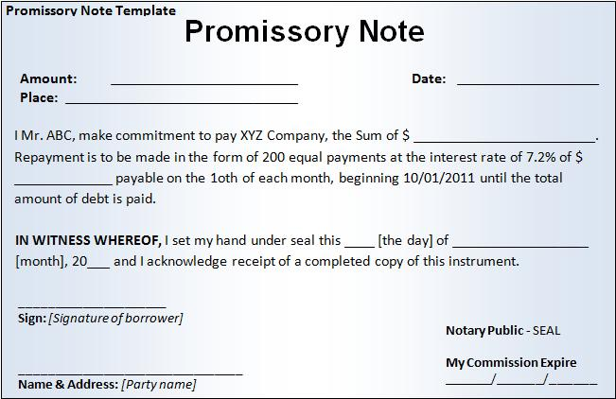
Related Articles:
- Bills of Exchange: This is an order from the creditor to the debtor. This instrument instructs the drawee (debtor) to pay the payee a certain amount of money. The bill will be made by the drawer (creditor)
- Cheque: This is just another form of a bill of exchange. Here the drawer is a bank. And such a cheque is only payable on demand. It is basically the depositor instructing the bank to pay a certain amount of money to the payee or the bearer of the cheque.
- Others: There are other instruments such as government promissory notes, railway receipts, delivery orders, etc. These can be negotiable instruments by custom or practice of the trade.

2.Bill of Exchange:

Definition of Bills of Exchange:
A bill of exchange is an instrument in writing containing an unconditional order, signed by the maker, directing a certain person to pay a certain sum of money only to, or to the order of, a certain person, or to the bearer of the instrument.

—Section 5 of the Negotiable Instruments Act, 1881.

Meaning:
Bill of exchange is a negotiable instrument which is payable either to order or to the bearer. Section 13 (1) of the Negotiable Instruments Act, 1881 defines negotiable instruments as “A promissory note, bill of exchange or cheque payable either to order or to bearer”.

A bill of exchange is generally drawn by the creditor on his debtor. It should be accepted either by the debtor or any person(s) on his/her behalf. It is worth mentioning that before its acceptance by the debtor, it is just a draft. It should be accepted either by a person upon whom it is drawn or someone else on his/her behalf. The stage at which the purchaser of goods signs the draft and writes ‘Accepted’ on it, it becomes a bill of exchange.

Example:

On 1.1.2011, Pawan sold goods to Harish on credit for Rs. 25,000. Pawan drew a bill for the same amount for two months and sent it to Harish for his acceptance on the same day. On 5.1.2011 Pawan got the acceptance of Harish. In this case, before 5.1.2011 it is known as mere draft. It becomes a bill of exchange only on 5.1.2011 when Harish accepted the bill.

Features of Bills of Exchange:
1. It should be in writing.
2. It is an order to make payment.
3. The order of payment is unconditional.
4. It should contain a certain amount to be paid.
5. The date of payment should be certain.
6. The amount must be payable either to a certain person or to his order or to the bearer of the bills of exchange.
7. It should be paid either on the expiry of a fixed period of time or on demand.
8. Bill of exchange must be signed by its maker.
9. In certain cases, it must be stamped also.
Parties to a Bill of Exchange:
There are three parties viz. ‘Drawer’, ‘Drawee’ and ‘Payee’ to a bill of exchange.

(i) Drawer:
A bill of exchange is drawn upon the buyer/debtor by the seller/creditor and the drawer is the person who makes and draws the bill. The drawer is entitled to receive money from the debtor.

(ii) Drawee:
The person upon whom the bill of exchange is drawn is known as drawee. Bill of exchange is drawn on the drawee who is the purchaser of goods. The drawee of a bill is called the acceptor when he writes the words “accepted” and puts his signatures on it. This process is known as acceptance.

After acceptance, the bill of exchange becomes a legal document. This document now binds the drawee to honour the bill on due date. This acceptance may be general or qualified. In the case of general acceptance, without stating any conditions, only signature of the accepter is required. However, in the case of qualified acceptance, name of the bank or specified place for payment is mentioned.

(iii) Payee:
The person to whom the payment is made is known as payee. In some cases, the drawer of the bill also becomes the payee when he himself keeps the bill till the date of maturity.

Drawer and Payee is usually the same person.

However, in the following cases drawer and payee are two different persons:

(i) When the bill is discounted by the drawer, the person who discounted the bill becomes the payee.

(ii) When the bill is endorsed to a creditor, the endorsee will become the payee.

Contents of Bills of Exchange:

The contents of bills of exchange are as under:

(i) Date:
The date of the bill on which it is drawn should be written on the top right comer of the bill. This aspect is very important to determine the maturity date of the bill.

(ii) Term:
This is the tenure of the bill and runs from the date of the bill. This should be specified in the body of the bill. Grace period of three days should be given after the expiry of the term from the date of the bill.

(iii) Amount:
Amount of the bill should be given both in figures and words. Amount in figures should be mentioned on the top left corner of the bill and amount in words should be mentioned in the body of the bill.

(iv) Stamp:
Stamp of proper value which depends on the amount of bill shall be affixed on the bills of exchange.

(v) Parties:
There may be three parties to the bills of exchange, drawer, drawee and payee. However, in some cases drawer and payee may be the same person. All the names of the parties and their addresses should also be invariably mentioned in the bills of exchange.

(vi) For Value Received:
This aspect is most important in the sense that law does not consider those agreements which have been made without consideration. Consideration means in lieu of and in the context of bills of exchange, it means that the bill has been issued in exchange of some consideration i.e., benefit has already been received.

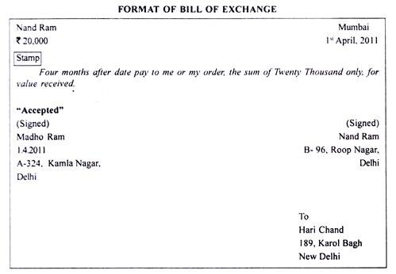

Advantages of Bills of Exchange:
The bills of exchange are used frequently in business as an instrument of credit due to the following reasons:

(i) Legal Relationship:
Issuing bills of exchange provides a framework which converts and establishes a legal relationship between seller and buyer, from creditor and debtor to drawer and drawee. In the case of any dispute between the parties, this relationship provides a conclusive proof in the court of law.

(ii) Terms and Conditions:
Bill of exchange contains all terms and conditions of payments viz., amount of the bill, date of payment, place of payment, interest to be paid, if any. The maturity date of the bill is also known to the parties of the bill so they can make necessary arrangement for funds

(iii) Mode of Credit:
Bill of exchange has been defined as a negotiable instrument under the Negotiable Instruments Act, 1881. The buyer can buy the goods on credit and pay after the period of credit with the help of bill of exchange. In case of urgency, the drawer can also get the payment through discounting the bill from the bank and without waiting for the maturity period.

(iv) Easy Transferability:
Bill of exchange can be used for settling the debt of the creditors. Mere delivery and endorsement of the bill give a valid title to the endorsee.

(v) Wider Acceptance:
In case of foreign bill, wider acceptance is given to the parties through which payments can be received and made easily.

(vi) Mutual Accommodation:
Sometimes, bill can be issued for mutually accommodating the parties so that financial help can be given to each other.
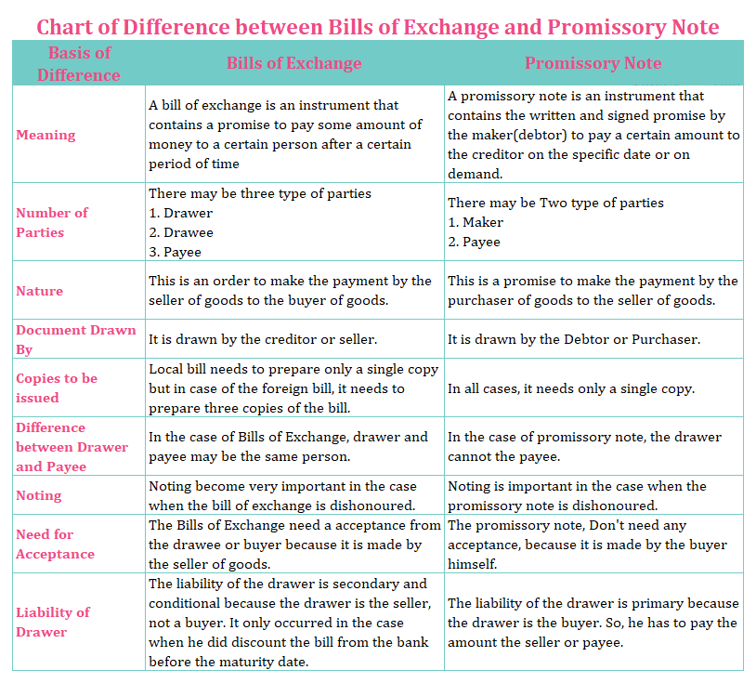

Types of Bill of Exchange on the Basis of Period:
On the basis of period bills are of two types:
- Demand bills
- Term bills

Demand Bills of Exchange:
There is no fixed date for the payment of such bill. They become payable at ay time, when they are presented before payee by the holder.

Tem Bills of Exchange:
These bills are payable after specified period of time. The period after which these bill become due for payment is called tenor.

Types of Bill of Exchange on the Basis of Object:
On the basis of purpose of writing the bills, the bills can be classified as:
- Trade Bills
- Accommodation Bills

Trade Bills:
These bills are drawn and accepted against the sale and purchase of goods on credit. These are drawn by the seller (creditor) and accepted by the buyer (debtor).

Accommodation Bills:
Such bills do not involve any sale and purchase of goods, rather they are drawn without any consideration. The purpose of such bills is to help one party or both the parties financially.

Classification of Bills of Exchange:
The bills can be classified into two classes given as under:

Inland Bill:
These bills are drawn in a country upon person living in the same country or made payable in the same country. Both drawer and the drawee reside in the same country.

Foreign Bills:
These bills are drawn in one country and accepted and payable in another country, e.g. a bill drawn in England and accepted and payable in India

Speciman of Bill of Exchange

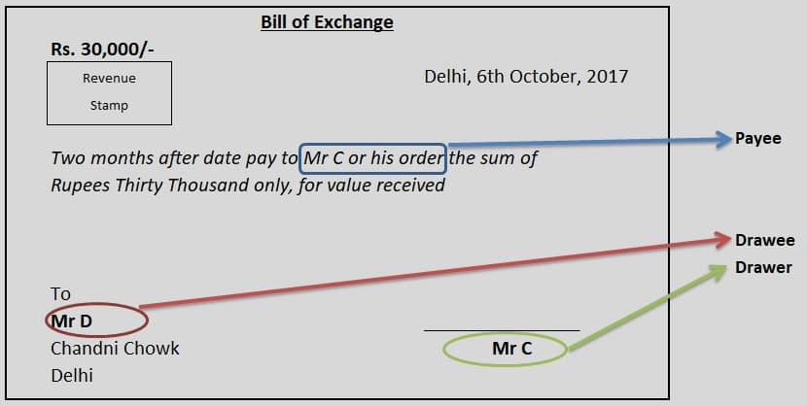

In the above example:
- Mr C is the creditor and drawer of the bill
- Mr D is the debtor and drawee of the bill
- Tenure of Bill is two months
- A certain amount i.e Rs 30000 is to be paid by the drawee
- Mr C is the payee here. The words “or his order” after Mr C in the bill denotes that Mr C can endorse the bill in favour of someone who will, upon such endorsement, become the payee of the bill.
Now assume that Mr C has also written the name of Mr G (the mutual friend who assured the creditworthiness of Mr D) on the bill as Drawee in case of need. In such case, if the bill is not accepted or dishonoured by Mr D (original drawee) then it would be presented to Mr G for acceptance and payment. If Mr G also refuses to accept or pay then the bill will be considered as dishonoured.
- Cheque:

Meaning of Cheque – Different Types of Cheque : Cheque is a negotiable instrument used to make payment in day to day business transaction minimizing the risk and possibility of loss. It is used by individuals, businesses, corporate and others to transact for making and receiving payment.

Definition of Cheque – What is a Cheque ?
As per negotiable instrument act 1881, A “cheque” is a bill of exchange drawn on a specified banker and not expressed to be payable otherwise than on demand.

Parties in cheque Transaction:

There are three parties in Cheque Transaction – Drawer, Drawee and Payee.
- Drawer (Maker of Cheque) – The person who issue the cheque or hold the account with bank.
- Drawee – The Person who is directed to make the payment against cheque. In case of cheque, it is bank.
- Payee – A person whose name is mentioned in the cheque or to whom the drawee makes payment. If drawer has drawn the cheque in favour of self then drawer is payee.
Payment by Cheque is safest way to conduct business transactions as it helps to maintain record in account statement to whom the payment is made by whom payment is received. So it becomes easier to track the transactions through bank account statement.
Types of Cheque:
There may be different types of Cheques depending on how the drawer has issued the Cheque.
- Open / Bearer Cheque
- Order Cheque
- Crossed Cheque
- Anti Dated Cheque
- Post Dated Cheque
- Stale Cheque
- Mutilated Cheque

- Open Bearer Cheque:

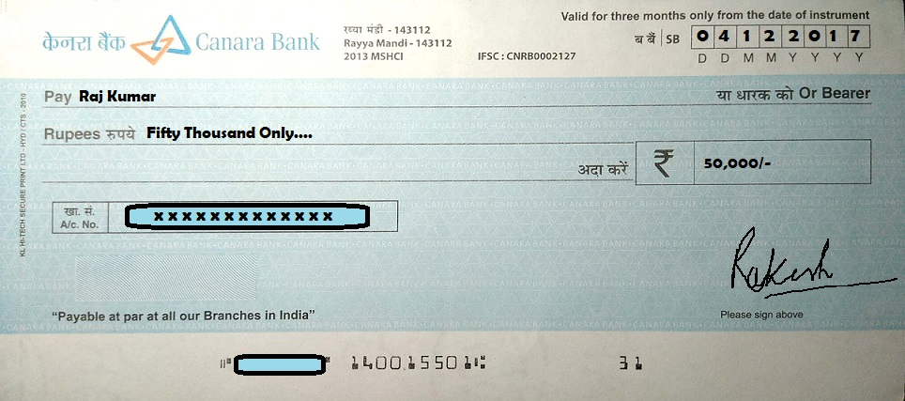

This type of Cheques are risky in nature for drawer. When the word “Bearer” on the cheque is not crossed or cancelled, the cheque is called a bearer cheque. Open / Bearer Cheques are payable to person specified in the instrument or any person who posses it and present for payment over the counter. In case of cheque is lost, person who find it can collect payment from the bank.

2.Order Cheque

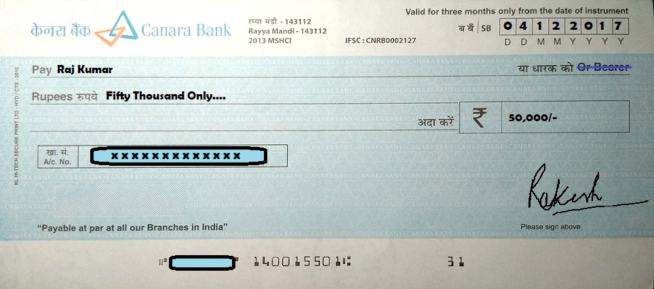
When the word “Bearer” written on cheque is crossed or cancelled it becomes an order cheque. An order Cheque is payable to a specified person named in the cheque or any other to whom it is endorsed.

3.Crossed Cheque or Account Payee Cheque

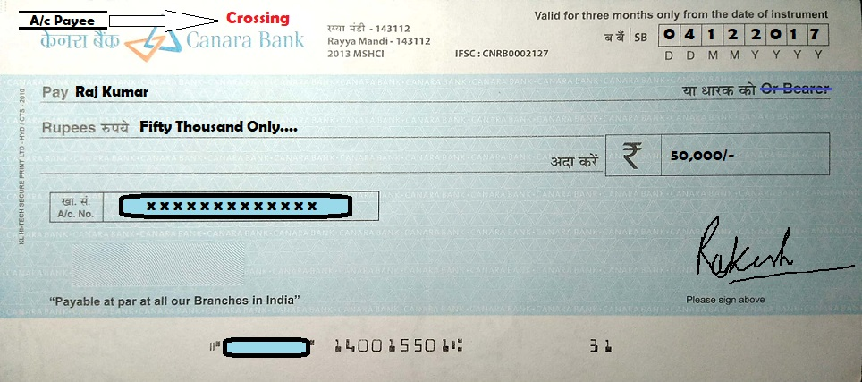

The person who issue or write the cheque specify its as account payee by simply making two parallel lines on top left or middle or right hand corner of the cheque. This type of cheque can not be encashed over the counter. Considered as safest type of cheque, it can only be credited to payee’s account whose name is mentioned in the Cheque.

4.Anti Dated Cheque

Cheque bearing the date earlier than the date of presentation for payment is known as anti dated cheque.

Note : All Types of Cheque are valid for three month from the date of issue (or written on cheque).

5.Post Dated Cheque

Cheque bearing the date which is yet to come in future is called Post Dated Cheque. Cheque is honored only on or after the date (upto three months) written on cheque.

6.Stale Cheque

A Cheque turns stale after three months of the date written on cheque. A Stale Cheque can not be honored by the bank.

7.Mutilated Cheque
When cheque gets torn into two or more pieces and presented in bank for payment. Such cheques are called mutilated cheque. Bank requires confirmation by the drawer before honoring such cheques.

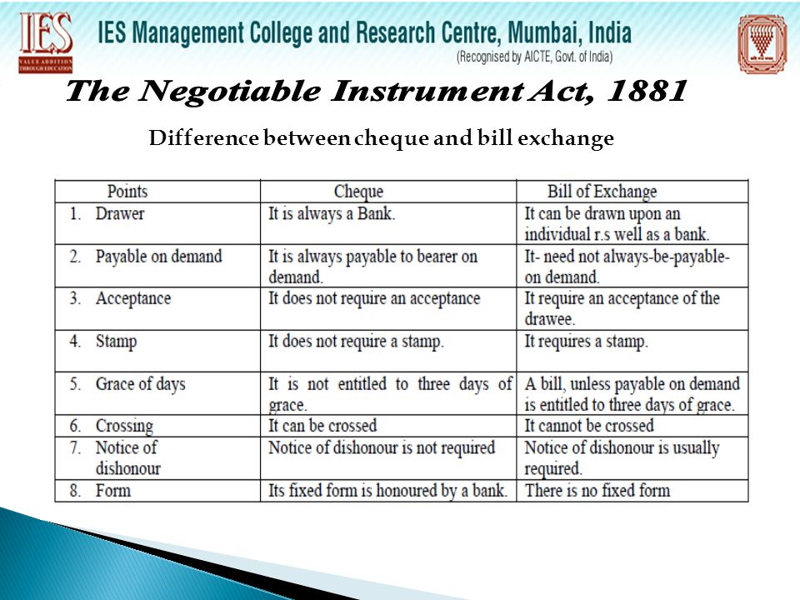

CROSSING OF CHEQUES
Crossing of Cheques means to draw two lines transverse parallel on left hand corner of the cheque.It directs the bank to deposit the money directly into the account and not to be pay cash at the bank counter.

MODES OF CROSSING
Below are the modes of crossing of cheques and the effect of crossing of cheques:

(1) GENERAL CROSSING - When a cheque bears two transverse parallel lines at the left hand of its top corner. Words such as 'and company' or any other abbreviation (such as & co.) may be written between these two parallel lines, either with or without words 'not negotiable', is called General Crossing.
Effect - Payment can be paid through bank account only, and should not be made at counter of paying bank.
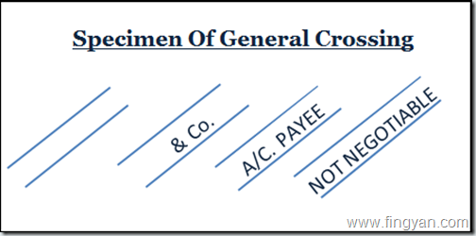
(2) SPECIAL CROSSING - When a cheque bears the name of the bank in between the two parallel lines, with or without the words 'not negotiable' is called Special Crossing.
Effect - The bank will pay to the banker whose name is written in between the crossing lines.

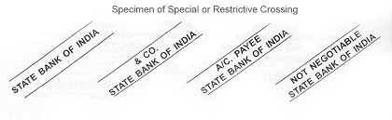

- RESTRICTIVE CROSSING / ACCOUNT PAYEE CROSSING - In this, crossing of cheques is done by writing Account Payee or Account Payee only in between the crossing lines.
Effect - Payment will be credited to the account of payee named in the cheque.
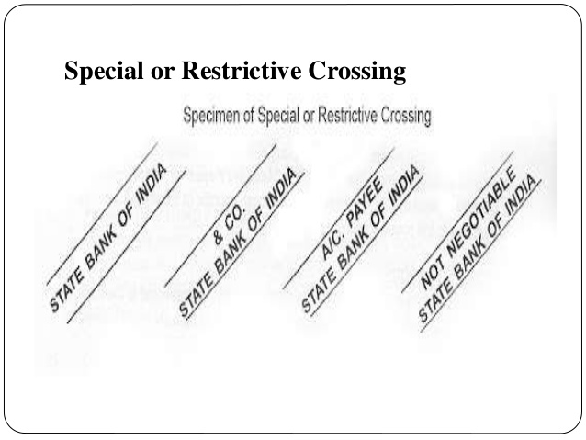

(4) DOUBLE CROSSING - When a cheque bears two special crossing, is called Double Crossing. In this second bank act as agent of the first collecting banker. It is made when the banker in whose favour the cheque is crossed does not have branch where the cheque is paid.

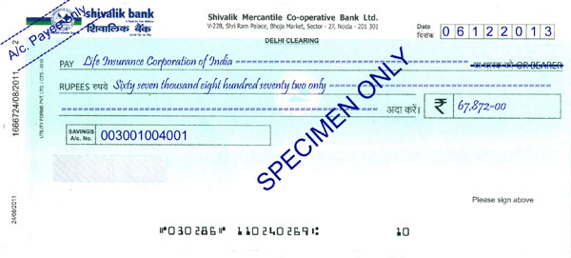

Who May cross a Cheque?
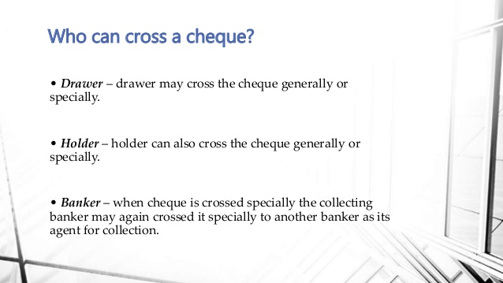

Endorsement:

Meaning:

Endorsement is made for the purpose of negotiation of a negotiable instrument by the maker or holder of a negotiable instrument by signing on the face or backside of an instrument or on a lip of paper called ‘allonge’#. Endorsement is explained under section 15 of Negotiable Instrument Act, 1881.
Cheque, Bill of Exchange and promissory note can be endorsed and an endorsement is made by maker or holder of an Negotiable Instrument. There is no limitation on number of instruments. A minor (defined under section 3 of Majority Act, 1875) can endorse a negotiable instrument under section 26 of negotiable instrument act but he will not be liable as an endorser.
Essentials of a Valid Endorsement:

1. It must be on the instrument. The endorsement may be on the back or the face of the instrument and if no space is left on the instrument, it may be made on a separate paper attached to it called along.
2. It must be an endorsement of the entire bill. A partial endorsement that is which purports to transfer to the endorse a part only of the amount payable does not operate as a valid endorsement.
3. It must be made by the maker or holder of the instrument. A stranger cannot endorse it.
4. It may be made either by the endorser merely signing his name on the instrument or by any words showing an intention to endorse or transfer the instrument to a specified person.
5. It must be signed by the endorser. It is not necessary to write the full name initial may be sufficient. Thumb- impression should be attested.
6. It must be completed by delivery of the instrument. The delivery must be made by the endorser himself or by somebody on his behalf with the intention of passing property therein.
Effects of endorsement
The endorsement of a negotiable instrument followed by delivery transfers to the endorsee the property therein with the right of further negotiation, but the endorsement may by express words, restrict or exclude such right, or may merely constitute the endorsee an agent to endorse the instrument, or to receive its contents for the endorser, or for some other specified person.
Illustrations
B signs the following indorsements on different negotiable instruments payable to bearer,-
(a) "pay the contents to C only".
(b) "pay C for my use".
(c) "pay C on order for the account to B".
(d) "the within must be credited to C".
These endorsements exclude the right of further negotiation by C.
(e) "pay C".
(f) "pay C value in account with the Oriental Bank".
(g) "pay the contents to C, bring part of the consideration in a certain deed of assignment executed by C to endorser and others".
These endorsements do not exclude the right of further negotiation by C.

Types of Endorsement:

Different Types of Endorsements:
Blank Endorsement (Section 16(1) of NI Act): If the endorser sign his name only without adding any words or direction, the endorsement is said to be blank. This makes the instrument payable to bearer as per section 54 of NI Act.
Full Endorsement: Where the endorser signs his name and adds the name of endorsee specifically, the endorsement is called full. Paying bank gets valid discharge if the endorsement is regular. Example: “Pay to Mr. Bahubali or Order”
Restrictive Endorsement (Section 50 of NI Act): When the endorser add words like ‘Pay the Contents to Kattappa only’. The endorsee cannot endorse the instrument further.
Partial Endorsement (Section 56 of NI Act.): When an endorser transfers only a part of the amount of the negotiable instrument to the endorsee. Its not a valid endorsement for the purpose of negotiation and such instrument should not be paid.
Conditional Endorsement: An endorsement which stipulates some condition is called conditional endorsement. Example – ‘Pay to Mr Mahendra Bahubali when he visits Mahishmati ‘. The fulfillment of condition is binding between endorser and endorsee only. The paying bank is not bound to verify the fulfillment of such conditions.
Sans Recourse Endorsement: By adding the words like “Pay Bhallaladeva or order without recourse to me”the endorser excludes his liability. It is caution to endorsee.
Facultative Endorsement: When an endorser waives the condition of notice of dishonor.
Forged Endorsement: Endorsement made by a person other that the holder, by signing the name of holder, is called forged endorsement. All endorsees including a Holder or Holder in due course or holder for value subsequent to the forged endorsement do not derive any title to the instrument. The paying banker gets protection as per section 85 (I) provided the endorsement is regular.
Note #allonge – a slip of paper attached to the end of a document to give room for further endorsements.

Cancellation of Endorsement:

Section 40 in The Negotiable Instruments Act, 1881
Discharge of indorser’s liability.—Where the holder of a negotiable instrument, without the consent of the indorser, destroys or impairs the indorser’s remedy against a prior party, the indorser is discharged from liability to the holder to the same extent as if the instrument had been paid at maturity. Illustration A is the holder of a bill of exchange made payable to the order of B, which contains the following indorsements in blank:— First indorsement, “B”. Second indorsement, “Peter Williams”. Third indorsement “Wright & Co.”. Fourth indorsement, “John Rozario”. This bill A puts in suit against John Rozario and strikes out, without John Rozario’s consent, the indorsements by Peter Williams and Wright & Co. A is not entitled to recover anything from John Rozario.

- Negotiable by Custom or Usage

- Hundis:

Meaning of Hundis:An age-old tradition of business transactions, peculiar to India, Hundis are negotiable instruments written in various vernacular local languages in the country. The term is derived from the Sanskrit word hundi which means ‘to collect’. These are generally in the form of bills of exchange but may sometimes look like promissory notes in shape and contents.

In other words, a hundi, though a negotiable instrument, is not necessarily a bill of exchange as defined in the Act per se. Hundis are popular among Indian merchants, especially those operating in sub-urban areas, even today, and are governed by the Negotiable Instrument Act,1881 unless there is a local usage to the contrary.
For example, contrary to the Act, if the custom or usage in a particular area or part of the country allows interest on hundis drawn and payable for as many days after sight, it would be recognized as lawful.

Forms or Types of Hundis
The following are some of the popular forms of hundis.
- 1. Darshani hundi: A hundi payable at sight is called darshani hundi. It is negotiable and is like a demand bill. It may be sold at par or at premium or at discount. A darshani hundi should be presented for payment within a reasonable time of its receipt by the holder. If the drawer suffers a loss due to delay in presentment, holder shall be responsible for it.
- 2. Miadi hundi: Also known as muddati hundi, miadi hundi is one which is payable after a specified period of time like a ‘time bill’. Banks usually provide loans against the security of such hundis.
- 3. Shahjog hundi: This is a hundi made payable only to a Shah (a respectable person of financial worth and substance in the market). It may be miadi or darshani and can be transferred freely from one person to another by mere delivery but it is not payable to bearer. In some respects it is similar to a crossed cheque.
- 4. Namjog hundi: It is a hundi payable to the party named in the hundi or his order. Such a hundi is similar to a bill of exchange payable to order.
- 5. Dhanijog hundi: ‘Dhani’ in vernacular language means owner. Thus, a dhanijog hundi is one which is made payable to the owner, or a holder or bearer-owner. It is just like a bearer cheque and the holder of it becomes holder in due course if he takes it bona fide and for value.
- 6. Jokhmi hundi: The term ‘Jokhmi’ has been derived from the Hindi word ‘jokhim’ meaning ‘risk’. Such a hundi is usually drawn against goods shipped on a vessel and implies a certain risk involved in the shipment of goods. Jokhmi hundi, in fact, is a combination of bill of exchange and insurance policy and payable only when the goods arrive in safe and sound condition. If the goods are lost in transit, the consignor cannot claim payment of the hundi from the consignee, i.e., the drawee. Thus, a jokhmi hundi safeguards the interests of both, consignor and the consignee. It acts as a bill of exchange if the goods arrive safely and if the goods are lost or destroyed en route, such a bill works like an insurance coverage
- 7. Jawabee hundi: A hundi, which is in the form of letter or recommendation to a banker for payment of a certain sum of money to a specified person, is termed as jawabi hundi.
- 8. Zikri hundi: This is a hundi accepted for honour in writing on a Zikri chit (letter of protection) without being protested. It is drawn in the name of a specified person residing in the town or city where the hundi is payable. In case, acceptance is refused by the drawee or when a refusal is likely to occur, the hundi is furnished to the holder by some prior party to it.
- 9. Firmanjog hundi: The term Firman refers to order in vernacular language and therefore, a firmanjog hundi is made payable to the order of payee. It is just opposite of dhanijog hundi which is payable to the bearer only.

- Share warrant

Meaningof share warrant : A Share Warrant is a document issued by the company under its common seal, stating that its bearer is entitled to the shares or stock specified therein. Share warrants are negotiable instruments. They are transferable by mere delivery without registration of transfer.

- Dividend Warrant

Meaning of Dividend Warrant:A Dividend Warrant is an instrument by which a company pays dividend in the form of cash (money) back to its shareholders from the profits it has made out of its business operations.

4.Bank Draft
Meaning:A bank draft is a payment on behalf of a payer that is guaranteed by the issuing bank. Typically, banks will review the bank draft requester's account to see if sufficient funds are available for the check to clear. Once it has been confirmed that sufficient funds are available, the bank effectively sets aside the funds from the person's account to be given out when the bank draft is used. A draft ensures the payee a secure form of payment. And the payer's bank account balance will be decreased by the money withdrawn from the account.

5.Circular Notes:
Meaning:A circular note is a written request by a bank to its foreign correspondents to pay a specified sum of money to a named person. When presenting the note for payment, the person to be paid must produce a letter (containing the signature of an official of the bank and the person named) called a letter of indication, which is usually referred to in the circular note. Circular notes are generally issued against a payment of cash to the amount of the notes, but the notes need not necessarily be cashed, but may be returned to the banker in exchange for the amount for which they were originally issued.

- Bearer Debentures:
Meaning:The debentures which are payable to bearer and whose names do not appear in the register of debenture holders are known as “Bearer Debentures”. Coupons for interest are attached to the document and interest is paid to the holders as it falls due. Bearer Debentures are transferably by mere delivery.

- Debentures of Bombay Port Trust

Meaning:The debentures which are payable to bearer and whose names do not appear in the register of debenture holders are known as “Bearer Debentures”. Coupons for interest are attached to the document and interest is paid to the holders as it falls due. Bearer Debentures are transferably by mere delivery.

- Railway receipts
Meaning:Railway receipt means the receipt issued under section 65 of the Railways Act.1989. These are also a type of negotiable instruments issued with monetary values.means the receipt issued by Railway Administration on acceptance of goods and which entitles the consignee to take delivery of the goods at the Private Terminal at which the train terminates;

Unit 2: BANKER AND CUSTOMER RELATIONSHIP 10 Hrs
Introduction – Meaning of Banker – Bank - Meaning of Customer – General & Special Relationships.

Introduction :
INTRODUCTION

Banking is a service-oriented activity. The main functions of a bank are to accept deposits and lend money, in addition to taking care of investments. As per the Banking Regulation Act, 1949, Sec 5(b), banking means: “Accepting deposits for the purpose of lending or investment, deposits of money from the public, repayable on demand or otherwise and withdrawable by cheque, drafts, and orders or any other acceptable mode”.

WHAT IS A BANK?

A bank is a firm or a joint stock company formed for the purpose of dealing in money or credits.
Again, under the United Dominions Trust vs. Kirkwood (1966) which case occurred in the United Kingdom, a bank was defined as an organization that operated with the following objectives:

a) Accepting deposits from customers
b) Honouring cheques and other withdrawals from customers.
c) Maintaining all sorts of accounts and being recognized as a bank in the financial community

Definition of Bank

Section 5B of Banking Regulation Act, 1949 defines Banking.
'Banking means the accepting for the purpose of lending or investing, of deposits of money from the public, repayable on demand or otherwise and withdrawable by cheque, draft, order or otherwise.

Features of Bank:

1. Dealing in Money

Bank is a financial institution which deals with other people's money i.e. money given by depositors.

2. Individual / Firm / Company

A bank may be a person, firm or a company. A banking company means a company which is in the business of banking.

3. Acceptance of Deposit

A bank accepts money from the people in the form of deposits which are usually repayable on demand or after the expiry of a fixed period. It gives safety to the deposits of its customers. It also acts as a custodian of funds of its customers.

4. Giving Advances

A bank lends out money in the form of loans to those who require it for different purposes.

5. Payment and Withdrawal

A bank provides easy payment and withdrawal facility to its customers in the form of cheques and drafts, It also brings bank money in circulation. This money is in the form of cheques, drafts, etc.

6. Agency and Utility Services

A bank provides various banking facilities to its customers. They include general utility services and agency services.

7. Profit and Service Orientation

A bank is a profit seeking institution having service oriented approach.

8. Ever increasing Functions

Banking is an evolutionary concept. There is continuous expansion and diversification as regards the functions, services and activities of a bank.

9. Connecting Link

A bank acts as a connecting link between borrowers and lenders of money. Banks collect money from those who have surplus money and give the same to those who are in need of money.

10. Banking Business

A bank's main activity should be to do business of banking which should not be subsidiary to any other business.

11. Name Identity

A bank should always add the word "bank" to its name to enable people to know that it is a bank and that it is dealing in money.

Functions of Bank
THE MAIN FUNCTIONS OF A BANK

Accepting Deposits

During the course of the banking business, a banker has to receive deposits from the public. Deposits accepted are to be repaid on demand (demand deposits) or as per terms and conditions (term deposits) of business. These deposits can be withdrawn by cheques, drafts or any other acceptable mode (including crediting to the operative accounts). Customers are entitled to get back their deposits from the bank on demand. The bank is obliged to pay according to the scheme and terms and conditions agreed upon.

Lending Money

Deposits have to be used for lending or investment. A bank cannot lend all the money accepted by it as loans and advances. After keeping a certain portion of the deposits as Cash Reserve Ratio (CRR) and Statutory Liquidity Ratio (STL), the bank is allowed to lend as per the directives of the central bank. This is mainly to retain public confidence and to comply with the directives of the regulator.

Investing Money

Besides lending money, the other main function of a bank is to invest. While lending or investing, the bank is expected to take precautions and assess the quantum, the security applicable, the repayment capacity and other relevant factors, as well as the need of the person borrowing from the bank.

Other functions of a bank

These functions, as per Sec 6 of the Banking Regulation Act, 1949, include:

a) Collection of cheques and bills

b) Purchase and discounting of bills;

c) Safe custody facilities (Safe deposit lockers)

d) Handling foreign exchange transactions

e) Handling central and state government transactions

f) Payment of insurance premium, electricity and telephone bills

g) Acting as trustees, executors, administrators, attorneys on behalf of the customers

h) Purchase and sale of securities including shares for customers;

i) Issuing of credit/debt cards, providing ATM facility

Unit 3: BANKING OPERATIONS 18 Hrs
Collecting Banker: Meaning – Duties & Responsibilities of Collecting Banker – Holder for Value –
Holder in Due Course - Statutory Protection to Collecting Banker
Paying Banker: Meaning – Precautions – Statutory Protection to the Paying Banker – Dishonor of
Cheques – Grounds of Dishonor – Consequences of wrongful dishonor of Cheques.
Lending Operations: Principles of Bank Lending – Kinds of lending facilities such as Loans, Cash
Credit, Overdraft, Bills Discounting, Letters of Credit – NPA: Meaning, circumstances & impact –
regulations of priority lending for commercial banks.

Unit 4: CUSTOMERS AND ACCOUNT HOLDERS 12Hrs
Types of Customers and Account Holders - Procedure and Practice in opening and operating accounts
of different customers including Minors - Meaning & Operations of Joint Account Holders,
Partnership Firms, Joint Stock companies, Executors and Trustees, Clubs and Associations and Joint
Hindu Undivided Family.

Unit 5: BANKING INNOVATIONS 06 Hrs
New technology in Banking – E-services – Debit and Credit cards. Internet Banking, ATM,
Electronic Fund Transfer, MICR, RTGS, NEFT, DEMAT.

